**1. Application Layout Design**: Being an information system major, I drew diagrams to help the computer science major team paint a picture of how the application needed to be programmed. The images below are examples of the rough visual outlines drawn. There are more drawings that haven’t been uploaded yet. These are just some examples.

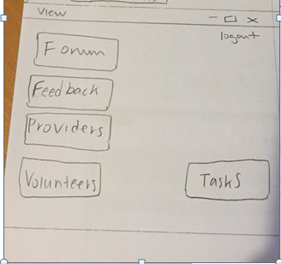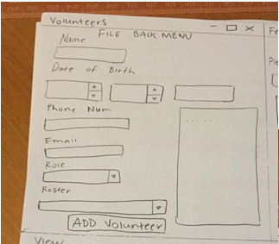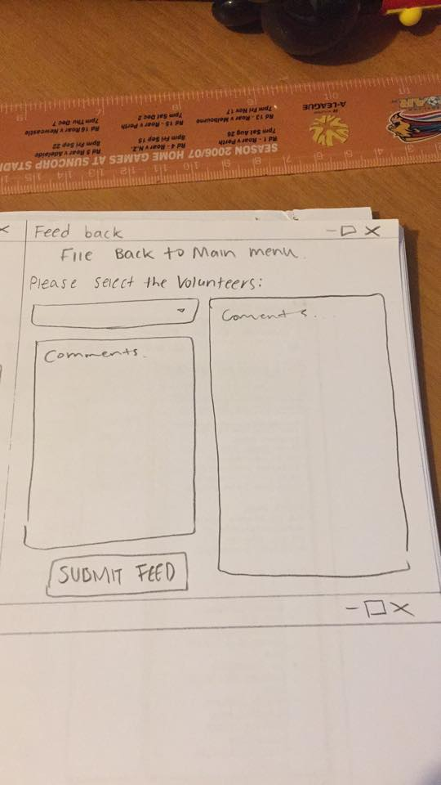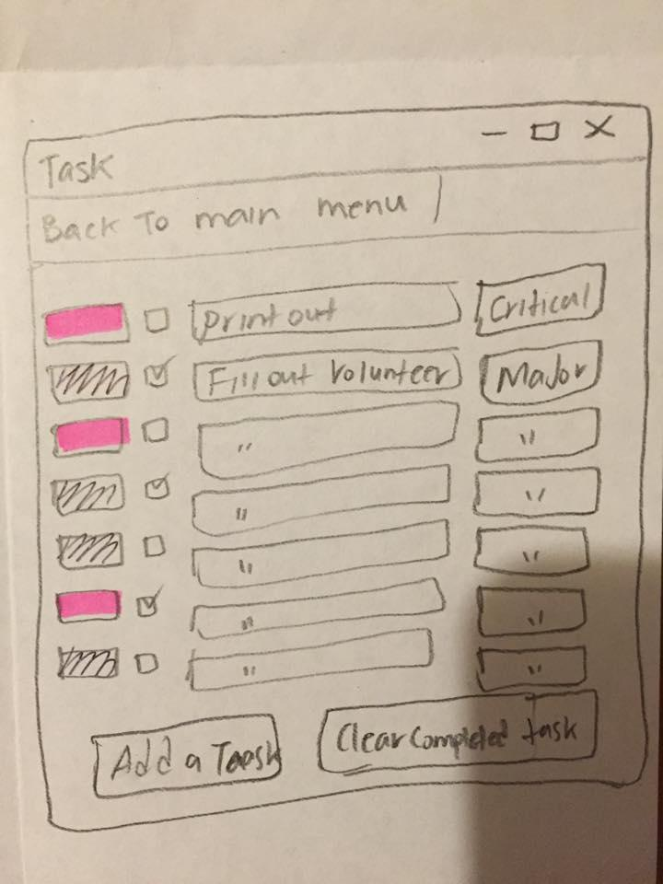

**2. Programming**: Though most of the coding was done by the computer science major team, I did contribute with one of the important sections. My contribution can be viewed here:

<https://github.com/MrMagic9/IFB299---The-cavalry---Help-Desk/blob/master/Helpdesk/main_form.cs> I understood that my programming skills were not of an exceptional level however I still pushed on to try my best to contribute as much as I could.

**3. Acceptance test**: This test was performed to check after sprint 3 and 4 was completed to test whether or not the user story would meet its ultimate goal. This test did not require the person being tested to have prior knowledge about how the application works.

**4. Feedback**: Friends and family who did not know how to use the application provided very straight forward responses. The feedback received included thoughts and opinions about the application’s usefulness, attractiveness, user friendliness and visibility. Based on the feedback from family and friends, the general consensus was positive and the design was well received. There were a few exceptions who m suggested changes and this feedback was useful in the tweaking and further improvement of the application.

**5. Client & development team liaison**: I attempted to uphold strong communication channels in and out of workshops with the development team so that both sides would have full awareness of the application’s development progress. My efforts also aimed to promote understanding and efficiency within the group.